TRANSMISSION DELAY VERSUS PROPAGATION DELAY

Name: LakshmiChaganti

WIU Id: 921421942

Webpage URL:<http://www.wiu.edu/users/lsc112/>

Git URl: <https://github.com/chagantila2/CN_PropDelay>

* Data is delivered to a network in the form of packets in computer networks, and this kind of data transport is known as packet switching.
* Packet switching, also known as virtual circuit switching
* There may be four delays in communication while transmitting data, the most prevalent of which being transmission and propagation delays.

Transmission delay:

* The length of time it takes to put all of the packet's bits into the wire/connection medium is known as transmission delay. It is the delay induced by the link's data rate.
* Store-and-forward delay and packetization delay are two terms that can be used to describe transmission delay.
* The length of the packet determines the transmission latency. It is proportional to the number of bits sent and inversely proportional to the transmission rate.
* Data size / Band width = Transmission delay.

Propagation delay:

* The time it takes for a signal to reach its destination is known as propagation delay.
* It refers to the time it takes for the signal's head to travel from the transmitter to the receiver.
* Wave propagation speed is inversely related to propagation delay and is directly proportional to distance.
* Distance / transmission speed = D / S = propagation delay

Project Requirements:

The below figures illustrate how the length, Rate, Packet size, start and reset options has been implemented.

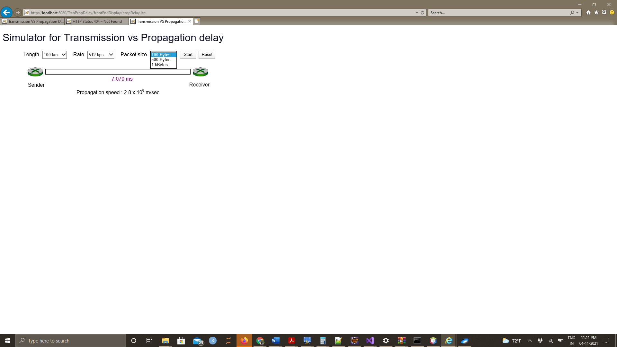

*Length dropdown requirements:*

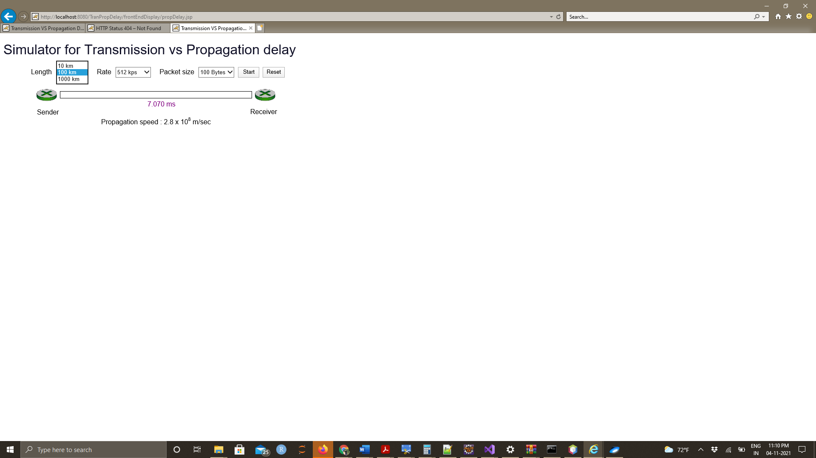

*Rate dropdown requirements:*

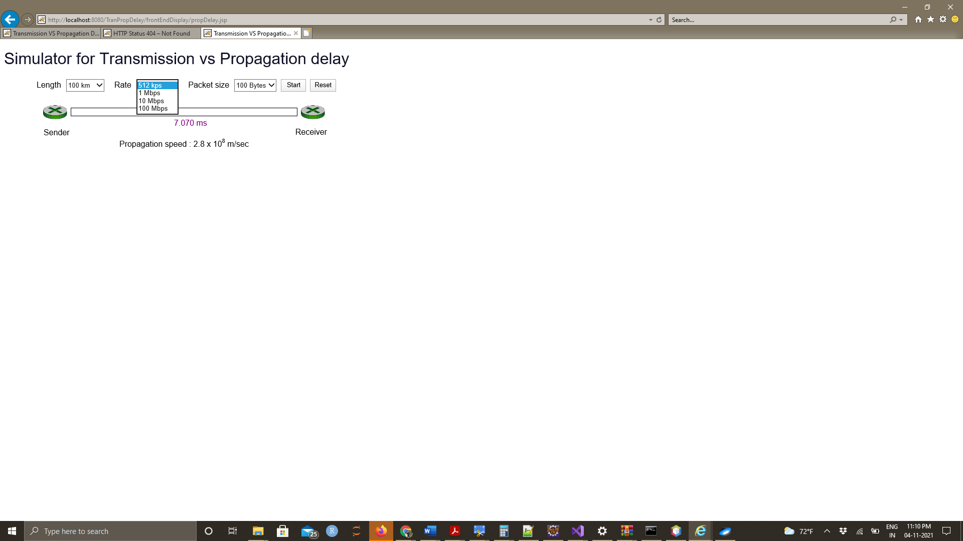

*Packet Size dropdown requirements*:



*Working:*

**Requirement**:

The Project Required to implement a simulator which illustrates one of the most fundamental concepts in computer networking**: transmission delay versus propagation delay.**

**Input**:

User can set following

1. the length of the link
2. the packet sizes
3. the transmission speeds
4. the simulator shows the packet being sent from sender to receiver.

**Result:**

**Input:**

Length:10KM

Rate: 512kbps

Packet Size: 100 bytes

**Output**

Time Taken : 7.007 ms

Testcase 1:

With a length of 10km, a rate of 1Mbps, a packet size of 100 bytes, and a propagation delay of 2.8* 108 m/sec, the propagation delay is set at 2.8* 108 m/sec. We'll look at the red colored bar above the connection, which indicates packet transit from sender to recipient.:

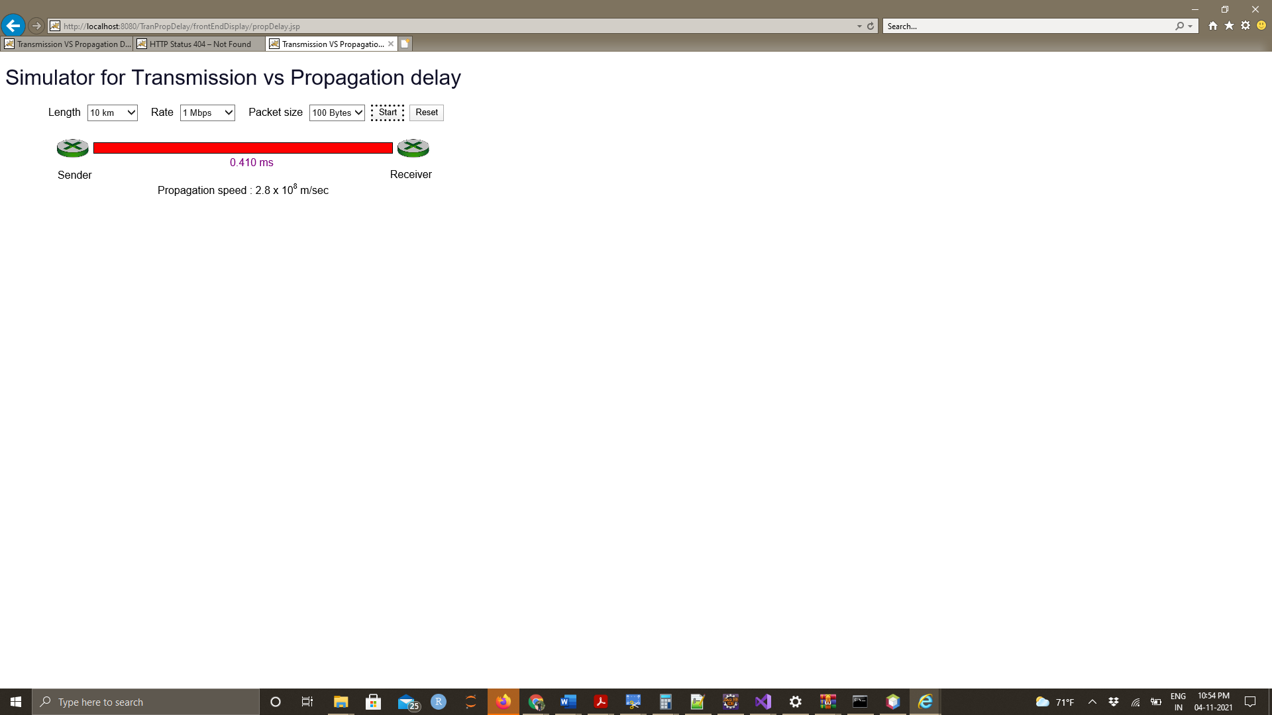

Testcase-2:

With Length of 10km, Rate of 512Mbps, packet size of 100 byte and the propagation delay of 2.8* 10^8 m/sec which is the fixed value. we will check with the red colored bar over the link which is the indication of movement of packets from sender to receiver:

When all the properties are set the packet:

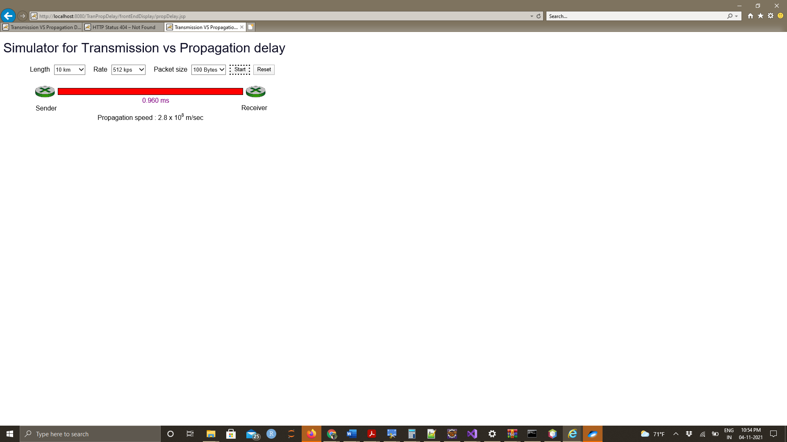

Testcase-3:

With the distance of 1000km, a data rate of 512Mbps, a packet size of 100 kilobyte, and a propagation delay of 2.8* 108 m/sec, the propagation delay is set at 2.8* 108 m/sec. We'll look at the red colored bar above the connection, which indicates packet transit from sender to receiver:

When all the properties are set the packet:

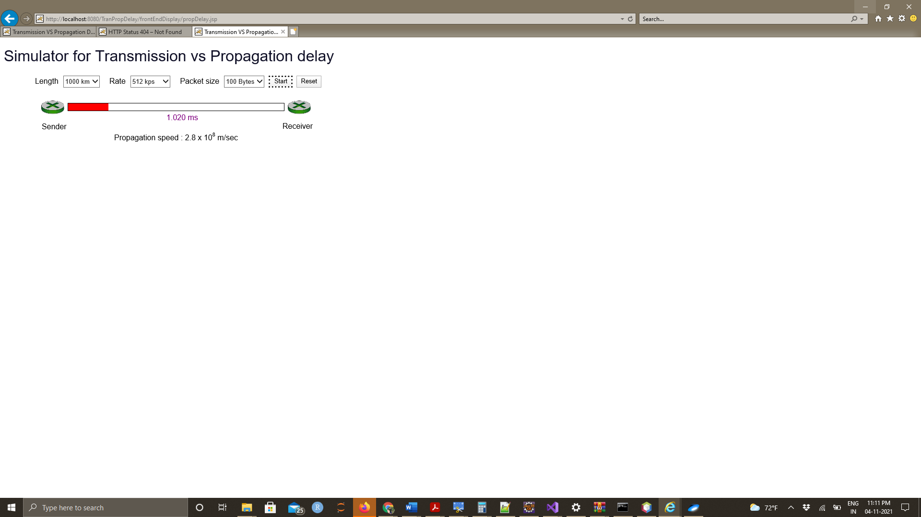

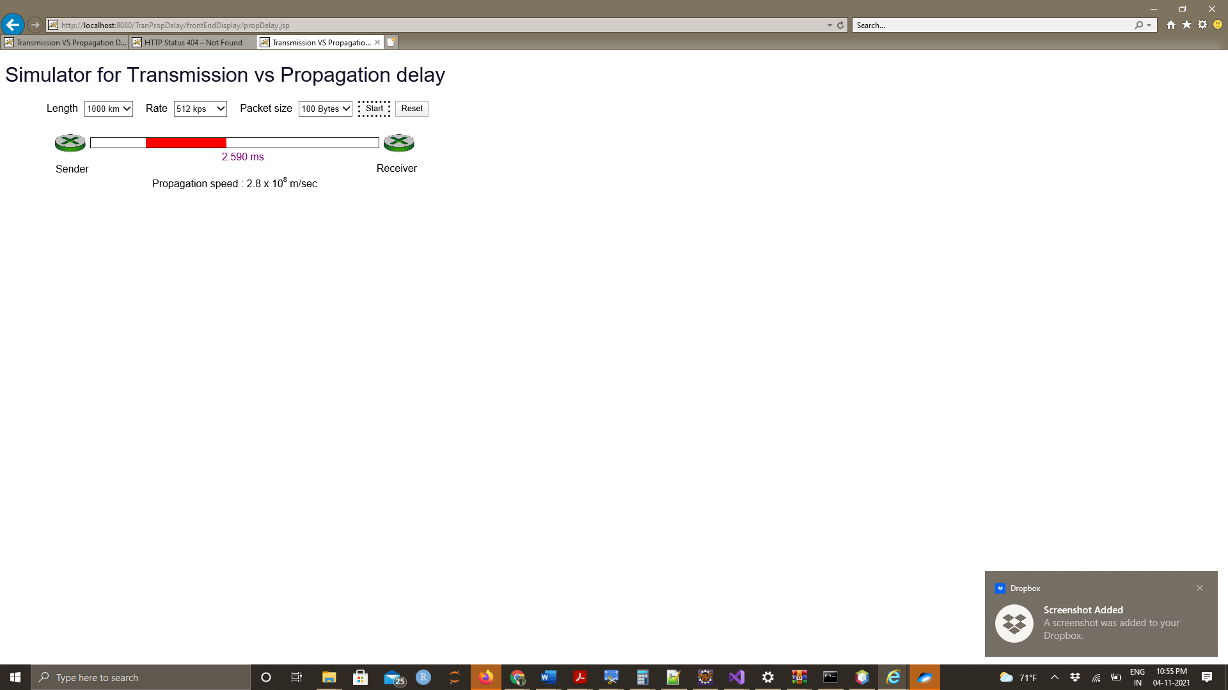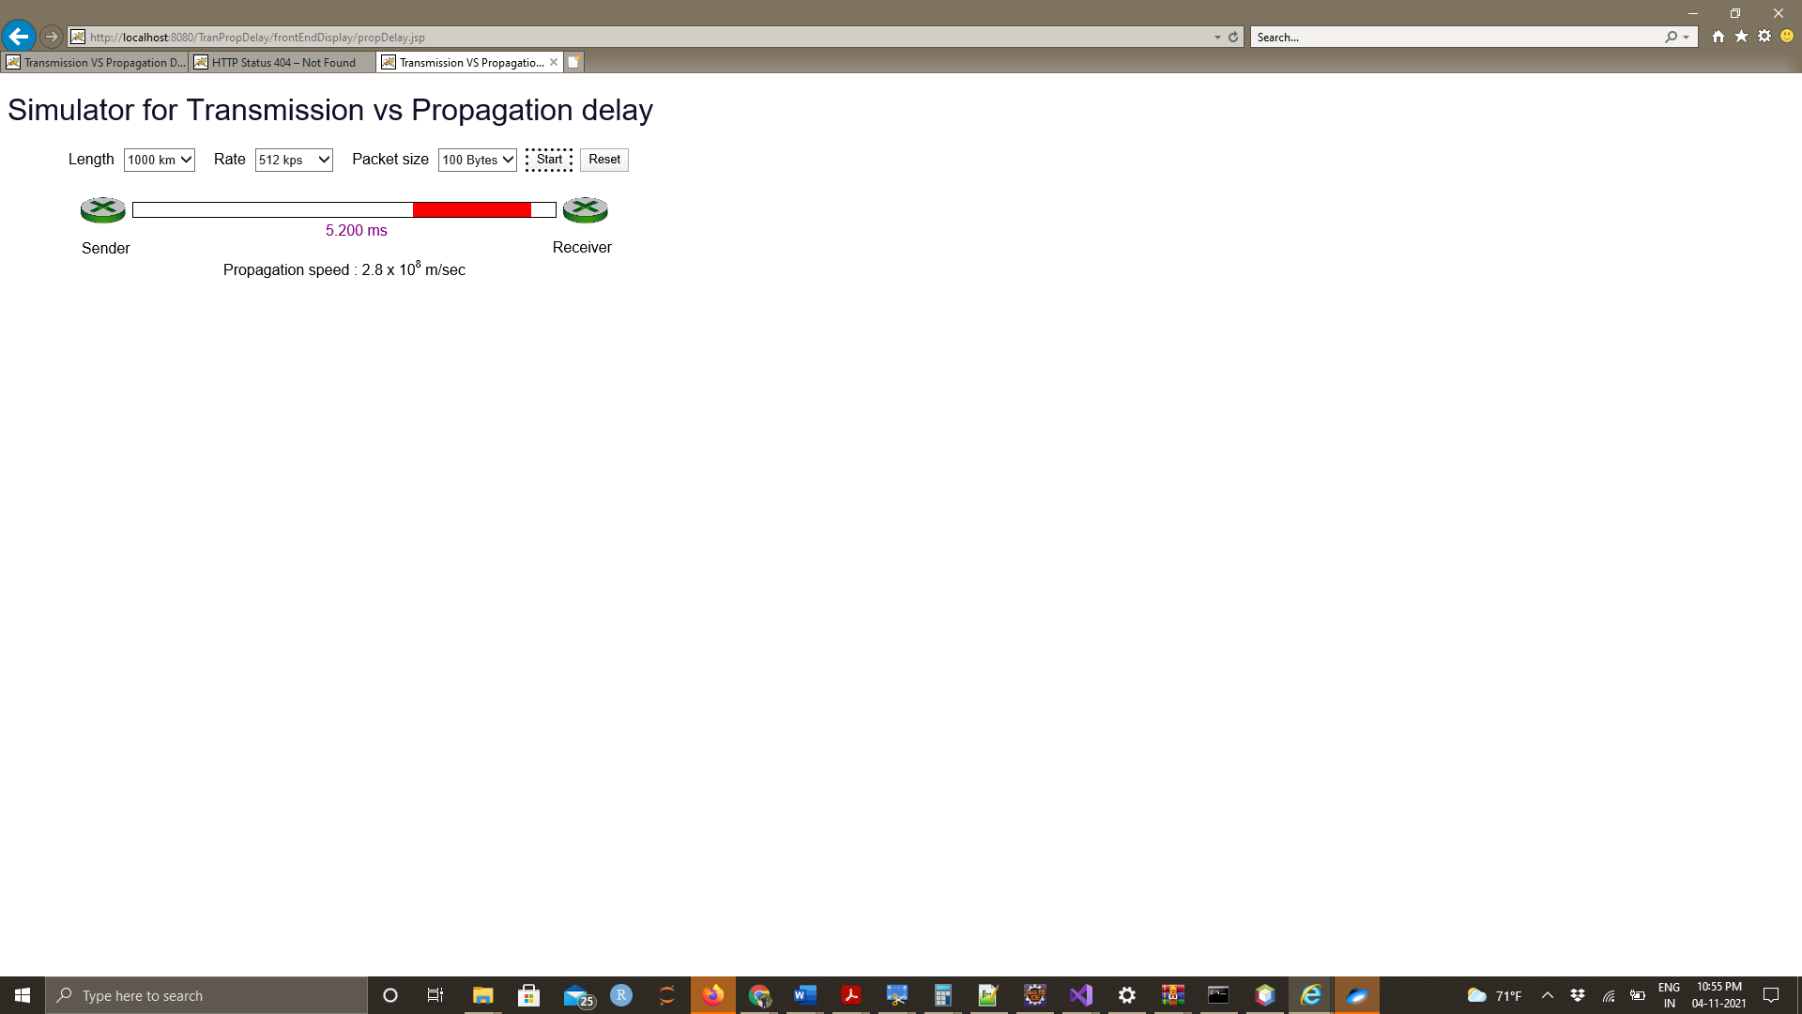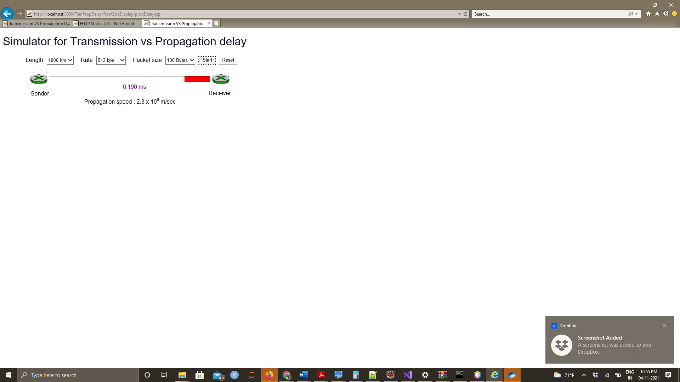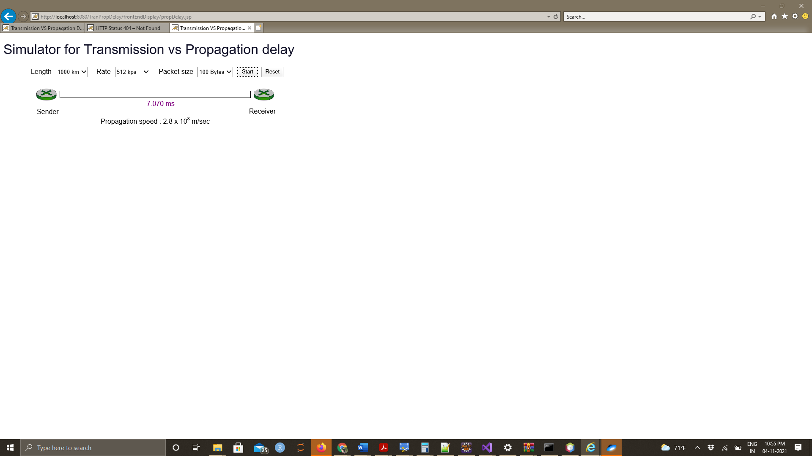

How to Execute

Step-1: Executing the program:

tranPropDelay🡪 sourcepackage 🡪 com.propdelay.controller🡪 propdelay.jsp (Right click)

Step-2: Need to set up the Tomcat server v9.0 before you start the execution.

Step-3: As soon as you follow the step-1 and run the program on server “Run on server” pops up and there “choose the existing server as Tomcat v9.0 server and click on Next tab at the bottom.

Step-5: After hitting the finish tab in step-4 the page gets redirected to local host with port address as 8080. Copy the url link from eclipse and follow the next step.

Step-6: Copy the link and paste it in your favorite browser

Step-7: You URL should contain:



<http://localhost:8080/TranPropDelay/frontEndDisplay/propDelay.jsp> We can see the web page with project requirements where we can test the packet delays.

WebPage URL:

<http://www.wiu.edu/users/lsc112/>